Assignment 4:
Heart Rate Variability (HRV)

Johannes Mämmelä
15027782
johannes.mammela@tuni.fi

- Introduction

Heart rate variability (HRV) describes the variation in the intervals between adjacent heartbeats, that is the fluctuation in the RR-intervals. Our brain and nervous system support our heart. Heart rate reflects the relative balance between sympathetic and parasympathetic nervous systems which are parts of the autonomic nervous system (ANS). Sympathetic nervous system controls the body’s responses to a perceived threat. It dominates when person is highly active and is responsible for the “fight or flight” response. In such situations, our body releases adrenaline so we can react faster. Then heart rate goes up just in case our muscles need more blood and oxygen. Conversely, parasympathetic nervous system controls homeostasis and the body at rest. It is responsible for the body’s “rest and digest” function. So, when the situation that put us into fight or flight mode is over, parasympathetic system takes a lead and tells heart to slow down and lowers the blood pressure. [1,2]

When heart rate is high, HRV is low because there is less time between heartbeats, so also less time for variability. Inversely when parasympathetic system predominates, heart rate is, but HRV is high because there is more time to vary. Body has many systems and features that let it adapt to where we are what we are doing. HRV reflects how adaptable our body can be. With higher variability, body can adapt better to many kinds of changes. HRV values also depend on for example patients age, physical condition, sleep/wake cycle, disease, and gender. Low HRV often implicates with conditions like diabetes, high blood pressure, asthma, or depression. [1,2]

HRV can be measured with ECG device in medical environment by detecting QRS-complexes and R-peaks of these. Additionally, nowadays there are several devices commonly used by athletes which are wrapped around chest with a band and can measure HRV sensitively and accurately. [2]

- Methods
2.1 RR-interval calculating
As said, typically HRV values are defined from ECG data by detecting R-peaks. This can be done with same kind of algorithm, for example Pan-Tompkins algorithm. However, in this assignment, we have a ready data which includes locations of R-peaks so this stage can be skipped. First, we must calculate distances between every consecutive R-peak. This can be done with a for-loop which goes through every index (except last one) of the data and calculates the difference between next one and that. After that the value is added to the distance vector. At this point distances are as indexes so these must be changed to seconds by dividing with sampling frequency which is 128Hz in this case. Then we want to plot every RR-interval as function of time, so we have to calculate the measurement time. This can be done by calculating, how many indexes are between first and last R-peaks and diving by sampling frequency. After that we can plot RR-intervals as a function of measurement time in hours. We can also plot a histogram where the intervals are in x-label and total counts of each interval duration are in y-label.
2.2 Statistical methods
HRV can be also estimated with statistical methods. These can be divided to two classes. One class includes those which are derived from direct measurements of NN-intervals (normal to normal) or instantaneous heart rate. Another group is these which are derived from the differences between NN-intervals. NN-intervals refer to the intervals between normal R-peaks but in this assignment, we are using all R-peaks, so we are using RR-intervals instead of NN-intervals. [3]
The simplest variable to calculate is the standard deviation of the NN interval (SDNN). Matlab has a simple command std for standard deviation calculation. SDNN reflects all the cyclic components responsible for variability in the period of recording. Typically, SDNN is calculated over a 24h period but our data is 22.5h long so we calculate over it. As the period of monitoring decreases, SDNN estimates shorter and shorter cycle lengths. It is also noticeable that the total variance increases with the length of recording. Based on that, SDNN is not a well-defined statistical quantity because of its dependence on the length of recording period. [3]
Another commonly used commonly used statistical method is called SDANN. The difference between SDANN and SDNN is the segments. SDANN calculates the standard deviation of the average interval over short periods, usually 5 minutes. 5-minute period length is also used in this assignment. So SDANN is an estimate of the changes in heart rate due to cycles longer than five minutes. For that permission, we must create a loop that divides our measurement to 5-minute segments. [3]
RMSSD, the square root of the mean squared differences of successive NN intervals and NN50, the number of interval differences od successive NN intervals greater than 50ms, are methods that calculate the variable derived from interval differences. pNN50 is the ratio between NN50 and the total number of intervals as percentages, so it is maybe more concrete. [3]
2.3 Geometrical methods
In addition to the statistical methods, there are also geometrical methods which can be used. For example, the triangular index measurement is the integral of the density distribution divided by the maximum of the density distribution. In discrete case the measure can be approximated by the following equation. [3]
Triangular index = total number of RR intervals/max. number of individual RR-interval length
The major advantage of geometric methods lies in their relative insensitivity to the analytical quality of the series of RR intervals and the biggest disadvantage is the need of reasonable number of RR intervals to construct the geometric pattern. [3]
2.4 Poincaré method
The last method used is the Poincaré plot. The idea of Poincaré plot is that each RR interval is plotted against next RR interval. Every interval is plotted as a function of previous interval. The analysis of Poincaré-figure is an quantitative-visual technique, where the shape of the plot is categorized into functional classes, that indicate the degree of the heart failure in a subject. The plot provides summary information as well as detailed beat to beat information on the behaviour of the heart. Plot may be analysed quantitatively by calculating the standard deviations of the distances of the RR-intervals to the lines y=x (SD2) and y=-x+2*mean(RR) (SD1). There SD1 is related to the fast beat to beat variability in the data, while SD2 describes the longer term variability of the RR intervals. Figure 1 presents the Poincaré plot of normal subject. [4]
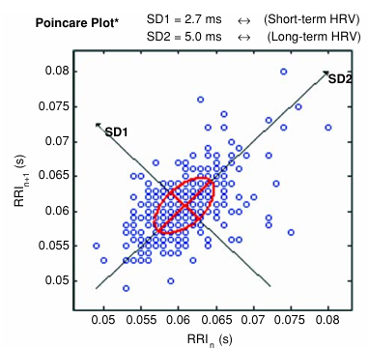
Figure 1: Poincaré plot [4]

- Results
RR intervals during the whole measurement plotted in figure 2.

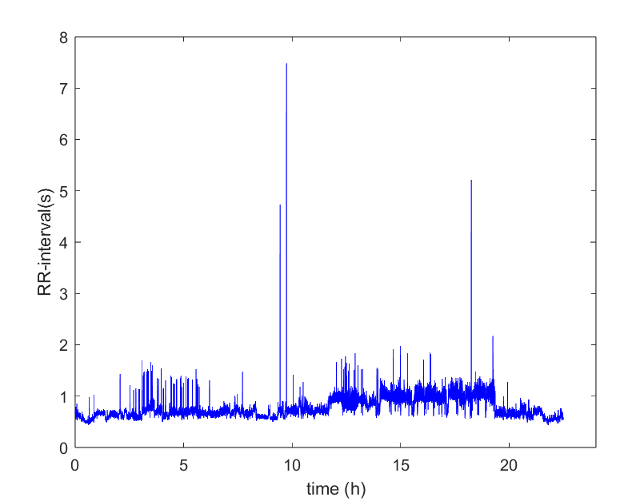
Figure 2: RR-intervals
If we take a look at the baseline in figure 2, it is seen that the value of it is about 0.7 s during the first about 12 hours, but then increases to the 1s until decreases again after 19 hours of measurement. That might tell us that the subject has slept the time between 13th and 19th hours because while person is sleeping, their heart rate is lower, and RR-intervals goes longer. Rest of the time subject is awake. Densifications and fluctuation on the baseline are due to artefacts. Artefacts are caused by several sources, and these are common for both healthy and clinical subjects. Typical artefact sources are body movements, measurement noise and poor contact of electrodes. The higher peaks like 1.5s to 2s peaks mean there are missed beats. While baseline goes about 0.7s, 1.5s interval means that heart has missed one beat. There is also a few abnormal hight peaks, like almost 8s and 5s RR-intervals, but these are clearly faults in a measurement because 8s interval would mean that the heart would miss about 8 to 15 beats in a row and that is not normal sinus rhythm anymore.
Statistical values presented below in table 1. I did not know the age or gender of the subject, but reference values have collected from 24-hour NN interval time series from 72 healthy subjects including 34 males, 37 females, age range 20 to 76 with mean age 55. [4]
Method |  | Reference values
SDRR | 172ms | 136.5 ±33.4 ms (SDNN)
SDARR | 156ms | 127.2 ± 35.7 ms
RMSSD | 58ms | 27.9 ± 12.3 ms
pRR50 | 8.8177 % | 7.5 ± 7.7 %
Table 1: Statistical values
Statistical values look quite normal. RMSSD value reflects beat to beat variance in heart rate and is the primary time-domain measure used to estimates the vagally mediates change reflected in HRV. It is also correlated with high frequency power. High frequency band is governed almost exclusively by parasympathetic effects so increase in RMSDD implicates that parasympathetic nervous system is taking a lead and subject is resting. HRV values declines with age too. Values I got are higher than reference values and these are near the top limit of the error margin so I our subject might be younger than 55. [4]

Histogram of the RR-interval counts as a function of intervals plotted in figure
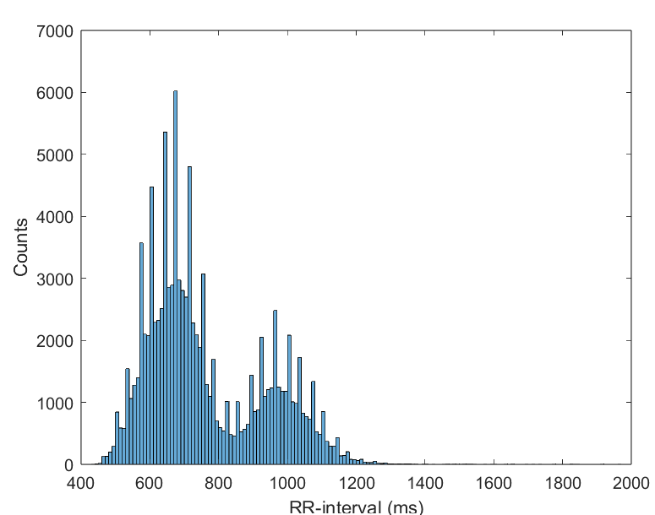
Figure 4: Histogram of the RR interval counts
There is also clearly seen two peaks. First peak is located around 700ms and the other around 1000ms which are the awake and sleep stages. The awake stage duration is much longer so the peak is also higher. Based on that figure, we can also define the triangular index by taking the count number of the highest peak and dividing the total number of RR intervals by it. So, the triangular index is 17.68. Advantage of triangular method is the hight insensitivity to artefacts and ectopic peak and thus is more precise than statistical values. However, in this assignment, as seen, the distribution is not one clear triangle but more likely two triangles. That is why the triangular method does not give so good estimate.

Last, we have the Poincaré method presented in figure 4.
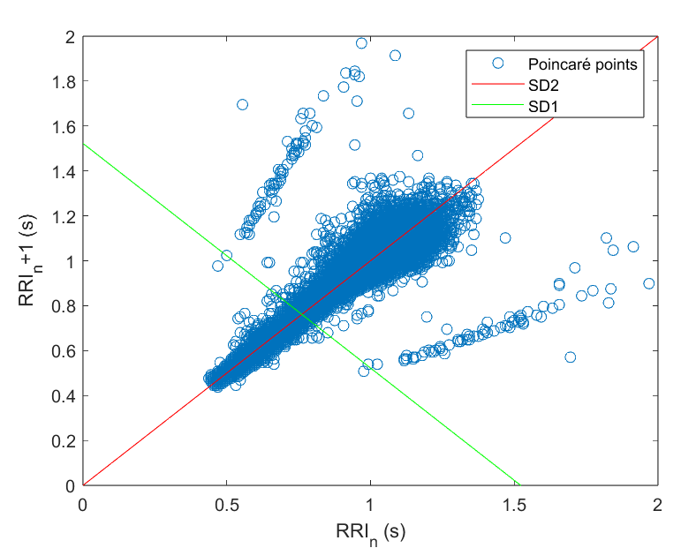
Figure 4: Poincaré points
The Poincaré plot also look normal in outline. Dispersion of plots looks good. Distribution is symmetrical and close which tell that the heart is healthy and balanced. Missed beats are seen as a straight lines both sides of the main distribution.
- Conclusion
Heart rate variability and monitoring of it is very big part of nowadays medicine. HRV is connected to many diseases and by measuring HRV these can be noticed and reacted early. Additionally, it is only used in detecting diseases. For example, pro athletes want to measure their HRV to optimize training and recovering to get better and better results. This assignment provided wider understanding of heart rate variability, behaviour of it and tools to estimate it. Key findings of the assignment were the successful results with those tools and analyse. The topic was very interesting to learn and that is why I personally read a lot more than required about it. Also, Matlab coding was suitably challenging for me.

5. Resources
[1] BBT.HTI.501 Processing of Biosignals, Lecture 8: Heart rate variability, [Referred 8.5.2024]. Available: https://moodle.tuni.fi/pluginfile.php/3804315/mod_resource/content/2/08_Heart_rate_variability.pdf
[2] Cleveveland Clinic, “Heart Rate Variability (HRV) (Last reviewed 09/2021). [Referred 8.5.2024]. Available: https://my.clevelandclinic.org/health/symptoms/21773-heart-rate-variability-hrv
[3] European Heart Journal, “Heart rate variability” (1996). [Referred 8.5.2024]. Available: guidelines-heart-rate-variability-ft-1996.pdf
[4] International Federation for Medical and Biological Engineering, “Heart rate variability: a review” (2006). [Referred 8.5.2024]. Available: HeartRateVariabilityAReview.pdf

- Matlab codes
